An econometric analysis on inequality

Introduction

In light of the symposium theme of inequality, I chose to investigate the correlation between GDP growth and inequality change.

Troubling times of closed borders, rising unemployment, and in some cases recessions, act as catalysts to reevaluate current economic systems and priorities. In such, lies the opportunity to improve our systems. However, this poses a new dilemma: what is an improvement? This article aims not to point towards a specific direction or an improved system, rather to inform the reader of the trends, so that they can formulate an informed decision or opinion.

Definition of Keywords

* Inequality: difference in size, degree, circumstances, etc.; lack of equality.[1]
* Gini Index: a summary statistic of income inequality, it ranges from 0 signifying perfect equality (equal share for everyone) to 1 signifying perfect inequality (one person gets all the income)[2]
* Gross Domestic Product (GDP): the total value of goods produced and services provided in a country during one year[3].
* The gross domestic product (GDP) growth rate: how fast components of an economy are growing.[4]
* Inflation Rate: a general increase in prices and fall in the purchasing value of money.[5]
* Purchasing Power: the financial ability to buy products and services.[6]
* Purchasing Price Parity (PPP): a rate of exchange between two currencies that gives them equal purchasing powers in their own economies[7]

Methodology

To begin with, it is important to note that simply measuring GDP growth is inadequate. Though it may seem that GDP growth is an unbiased measure, in reality it does not take into account three things:

1. inflation rate (larger inflation rate → larger GDP growth); solution is to measure 'real' growth
2. cost of living (more expensive countries → larger GDP); solution is to adjust for 'PPP'
3. population size (larger population → larger GDP growth); solution is to measure 'per capita'

Hence the more accurate measure is "Real + GDP + growth + PPP adjusted + per Capita". The source for the data I used is the Penn World Table Version 9.1[8] and the measures I used were 'RGDPe'/'Population'. Furthermore, for the data on inequality change I used the Gini Index based on income inequality calculated by the University of Texas Inequality Project (UTIP)[9].

It is also important to note I did not measure GDP correlation with Inequality, rather GDP ***growth*** and Inequality ***change***. This was to assure fair comparison between different countries. To calculate the correlation between these two factors, I coded a Python Notebook to select time periods when there was at least one Gini measurement every three years and a minimum of three measurements in total to allow for reasonable interpolation. The code and other resources can be found here: <https://github.com/pald22/Inequality>.

Research has been made on this topic, namely by Simon Kuznets a famous economist who has received a Nobel Prize in 1971 for his work in this subject[10]. One of his works after the Nobel Prize was on GDP correlation with Inequality but not change. His hypothesis was that as the economy first develops at Point A the inequality will rise. At some point the economy will reach point B and Inequality will start to decrease. Leading to a 'simplified' conclusion that economic growth is beneficial. Below is an example of the Kuznets curve:

Figure 1: Kuznets Curve

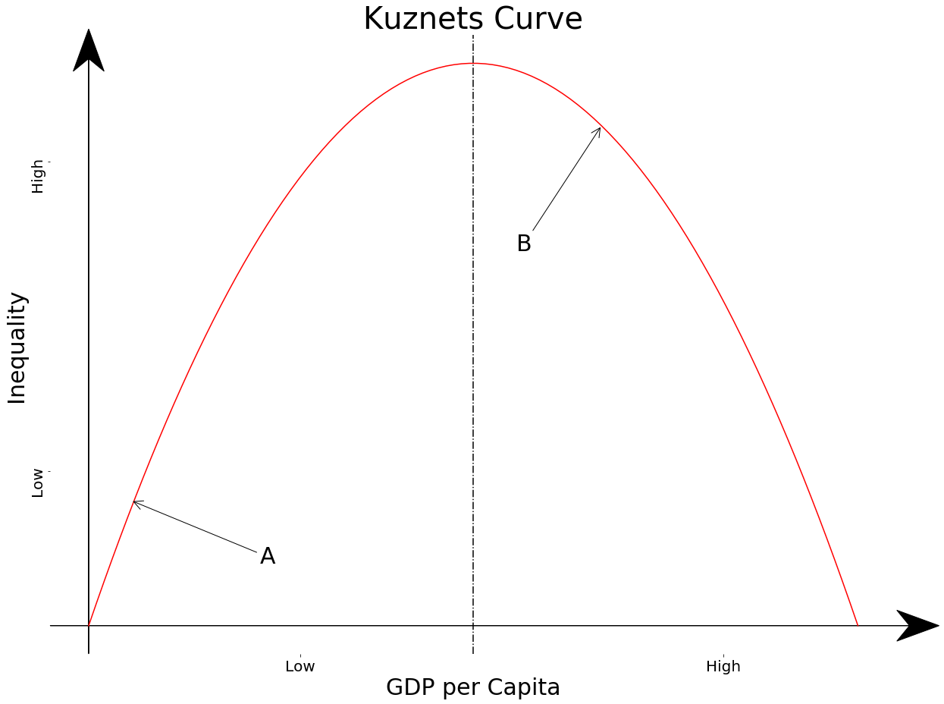

If his theory was correct, when I calculate the correlation between "Real GDP growth per Capita PPP adjusted" and "Inequality change", we will see some countries with positive correlation (Point A) and some countries with negative correlation (Point B).

Figure 2: Personal analysis of Correlation between GDP growth and Inequality Change

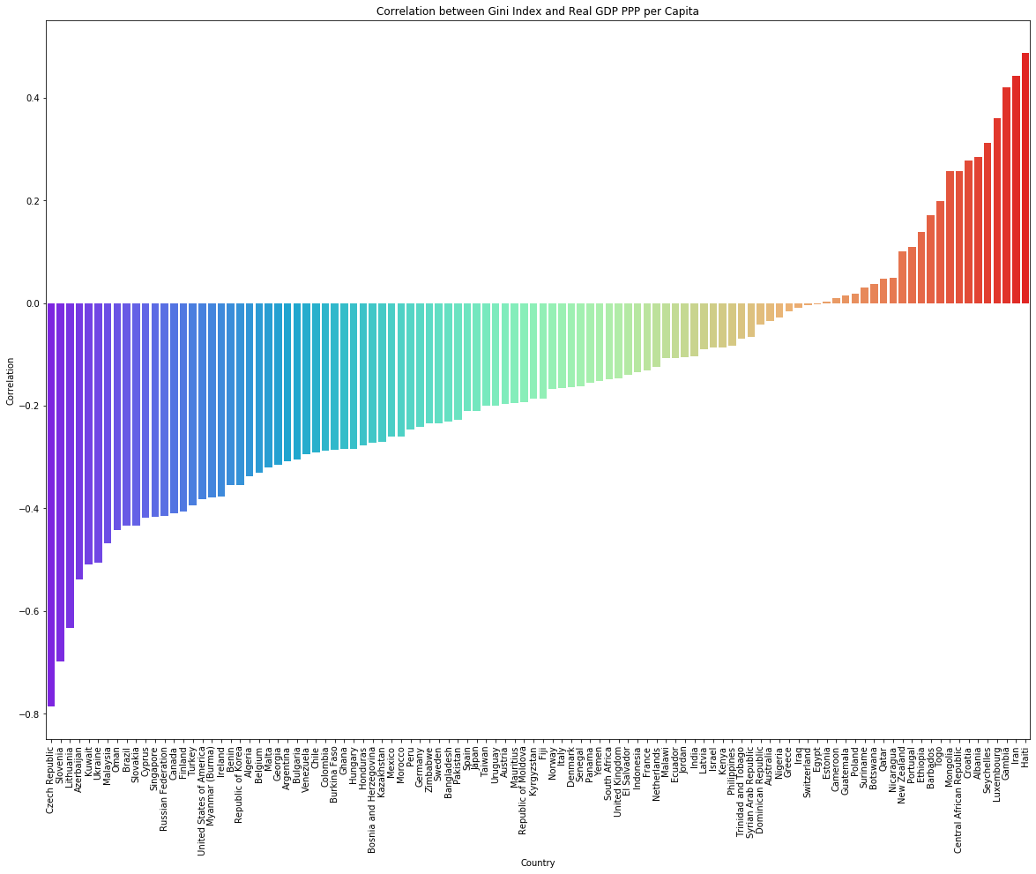

From the graph I produced we can see how the majority of the 'developed' countries (Point B) are in the negative zone, this is a good thing as it shows that after growth, inequality decreases. On the other side, there are 'less economically developed' countries with positive correlation such as Mongolia, Iran, and Gambia (Point B). Albeit there are some exceptions such as: Portugal, New Zealand, Croatia, and Luxembourg; however, they are dwarfed by the preponderance of evidence in favor of the Kuznets curve.

Conclusion

To summarise, there are two main takeaways: as countries develop, inequality rises and once these countries are sufficiently developed, the inequality can start decreasing. This would provide an explanation why certain countries have an increasing inequality and others have a decreasing inequality, because they are at different economic stages.

Bibliography

Oxford University Press 2020 inequality. In: Lexico.com , Available at: <https://www.lexico.com/definition/inequality> [Accessed 1st of September 2020].

Gini index def. by *census gov*. Accessed on the 1st of September 2020 <https://www.census.gov/topics/income-poverty/income-inequality/about/metrics/gini-index.html>

Oxford University Press 2020 inflation. In: Lexico.com , Available at: <https://www.lexico.com/definition/inflation> [Accessed 1st of September 2020].

Oxford University Press 2020 gross domestic product. In: Lexico.com , Available at: <https://www.lexico.com/definition/gross_domestic_product> [Accessed 2nd of September 2020].

Oxford University Press 2020 purchasing power. In: Lexico.com , Available at: <https://www.lexico.com/definition/purchasing_power> [Accessed 10th of September 2020].

"PPP." Collins English Dictionary – Complete and Unabridged, 12th Edition 2014. 1991, 1994, 1998, 2000, 2003, 2006, 2007, 2009, 2011, 2014. HarperCollins Publishers 2 Sep. 2020 <https://www.thefreedictionary.com/PPP>

Feenstra, Robert C., Robert Inklaar and Marcel P. Timmer (2015), "The Next Generation of the Penn World Table" American Economic Review, 105(10), 3150-3182, available for download at [www.ggdc.net/pwt](https://www.rug.nl/ggdc/productivity/pwt/related-research)

University of Texas Inequality Project "UNIDO" global data set. Available for download at <https://utip.lbj.utexas.edu/datasets.html> [Accessed 2nd of September 2020]

Feenstra, Robert C., Robert Inklaar and Marcel P. Timmer (2015), "The Next Generation of the Penn World Table" American Economic Review, 105(10), 3150-3182, available for download at [www.ggdc.net/pwt](https://www.rug.nl/ggdc/productivity/pwt/related-research)

University of Texas Inequality Project "UNIDO" global data set. Available for download at <https://utip.lbj.utexas.edu/datasets.html> [Accessed 2nd of September 2020]

The Sveriges Riksbank Prize in Economic Sciences in Memory of Alfred Nobel 1971. NobelPrize.org. Nobel Media AB 2020. Sat. 5 Sep 2020. <https://www.nobelprize.org/prizes/economic-sciences/1971/summary/>

1. Inequality def. - *Oxford University Press*
2. Gini index def. - *Census Gov.*
3. Gross Domestic Product def.- *Oxford University Press*
4. Gross Domestic Product Growth Rate def. - *The Balance*
5. Inflation def. - *Oxford University Press*
6. Purchasing Power def. - *Oxford University Press*
7. Purchasing Power Parity def. - *Collins English Dictionary*
8. Penn World Table Version 9.1 - *Groningen Growth and Development Centre Faculty of Economics and Business*
9. Gini Index of income inequality (UTIP-UNIDO data set) - *University of Texas Inequality Project.* 
10. Simon Kuznets Nobel prize - *Nobel Prize Org.*